**Java Multidimensional Arrays**

In this tutorial, we will learn about the Java multidimensional array using 2-dimensional arrays and 3-dimensional arrays with the help of examples.

Before we learn about the multidimensional array, make sure you know about [Java array](https://www.programiz.com/java-programming/arrays).

A multidimensional array is an array of arrays. Each element of a multidimensional array is an array itself. For example,

int[][] a = new int[3][4];

Here, we have created a multidimensional array named a. It is a 2-dimensional array, that can hold a maximum of 12 elements,

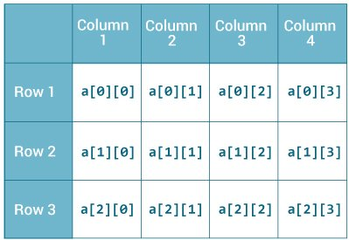2-dimensional Array

Remember, Java uses zero-based indexing, that is, indexing of arrays in Java starts with 0 and not 1.

Let's take another example of the multidimensional array. This time we will be creating a 3-dimensional array. For example,

String[][][] data = new String[3][4][2];

Here, data is a 3d array that can hold a maximum of 24 (3*4*2) elements of type String.

**How to initialize a 2d array in Java?**

Here is how we can initialize a 2-dimensional array in Java.

int[][] a = {

{1, 2, 3},

{4, 5, 6, 9},

{7},

};

As we can see, each element of the multidimensional array is an array itself. And also, unlike C/C++, each row of the multidimensional array in Java can be of different lengths.

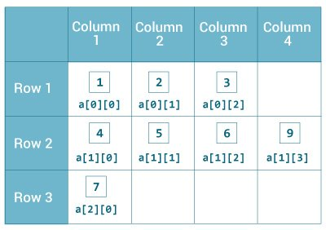Initialization of 2-dimensional Array

**Example: 2-dimensional Array**

class MultidimensionalArray {

public static void main(String[] args) {

// create a 2d array

int[][] a = {

{1, 2, 3},

{4, 5, 6, 9},

{7},

};

// calculate the length of each row

System.out.println("Length of row 1: " + a[0].length);

System.out.println("Length of row 2: " + a[1].length);

System.out.println("Length of row 3: " + a[2].length);

}

}

[Run Code](https://www.programiz.com/java-programming/online-compiler)

**Output**:

Length of row 1: 3

Length of row 2: 4

Length of row 3: 1

In the above example, we are creating a multidimensional array named a. Since each component of a multidimensional array is also an array (a[0], a[1] and a[2] are also arrays).

Here, we are using the length attribute to calculate the length of each row.

**Example: Print all elements of 2d array Using Loop**

class MultidimensionalArray {

public static void main(String[] args) {

int[][] a = {

{1, -2, 3},

{-4, -5, 6, 9},

{7},

};

for (int i = 0; i < a.length; ++i) {

for(int j = 0; j < a[i].length; ++j) {

System.out.println(a[i][j]);

}

}

}

}

[Run Code](https://www.programiz.com/java-programming/online-compiler)

**Output**:

1

-2

3

-4

-5

6

9

7

We can also use the [for...each loop](https://www.programiz.com/java-programming/enhanced-for-loop) to access elements of the multidimensional array. For example,

class MultidimensionalArray {

public static void main(String[] args) {

// create a 2d array

int[][] a = {

{1, -2, 3},

{-4, -5, 6, 9},

{7},

};

// first for...each loop access the individual array

// inside the 2d array

for (int[] innerArray: a) {

// second for...each loop access each element inside the row

for(int data: innerArray) {

System.out.println(data);

}

}

}

}

[Run Code](https://www.programiz.com/java-programming/online-compiler)

**Output**:

1

-2

3

-4

-5

6

9

7

In the above example, we are have created a 2d array named a. We then used for loop and for...each loop to access each element of the array.

**How to initialize a 3d array in Java?**

Let's see how we can use a 3d array in Java. We can initialize a 3d array similar to the 2d array. For example,

// test is a 3d array

int[][][] test = {

{

{1, -2, 3},

{2, 3, 4}

},

{

{-4, -5, 6, 9},

{1},

{2, 3}

}

};

Basically, a 3d array is an array of 2d arrays. The rows of a 3d array can also vary in length just like in a 2d array.

**Example: 3-dimensional Array**

class ThreeArray {

public static void main(String[] args) {

// create a 3d array

int[][][] test = {

{

{1, -2, 3},

{2, 3, 4}

},

{

{-4, -5, 6, 9},

{1},

{2, 3}

}

};

// for..each loop to iterate through elements of 3d array

for (int[][] array2D: test) {

for (int[] array1D: array2D) {

for(int item: array1D) {

System.out.println(item);

}

}

}

}

}

[Run Code](https://www.programiz.com/java-programming/online-compiler)

**Output**:

1

-2

3

2

3

4

-4

-5

6

9

1

2

3